Project Information Report - Godrej Aveline

1. Project Summary
Sales Status: Sustenance
Construction Status: Excavation

2. Configurations (all of them) & Pricing (in Crs.)
Configuration | Saleable Area/SBU Size (sq. ft.) | Agreement Value (Starting Price) | Pricing Range (Agreement Value + GST) | Pricing Range (Agreement Value + GST + SDR)
2 BHK Premium | 1288.11 sq. ft. | 2.2 Cr. | 2.2 Cr. + 5% | 2.2 Cr. + 5% + 7%
2 BHK Lux | 1437.63 sq. ft. | 2.35 Cr. | 2.35 Cr. + 5% | 2.35 Cr. + 5% + 7%
2.5 BHK Lux | 1663.63 sq. ft. | 2.61 Cr. | 2.61 Cr. + 5% | 2.61 Cr. + 5% + 7%
3 BHK Premium | 1593.87 sq. ft. | 2.89 Cr. | 2.89 Cr. + 5% | 2.89 Cr. + 5% + 7%
3 BHK Lux | 1908.05 sq. ft. | 3.3 Cr. | 3.3 Cr. + 5% | 3.3 Cr. + 5% + 7%
3.5 BHK Lux | 2195.39 sq. ft. | 3.8 Cr. | 3.8 Cr. + 5% | 3.8 Cr. + 5% + 7%
4.5 BHK Lux | 2491.16 sq. ft. | 4.6 Cr. | 4.6 Cr. + 5% | 4.6 Cr. + 5% + 7%

3. RERA: Possession & OC Timelines
- RERA Number: PRM/KA/RERA/1251/309/PR/020326/008501
- RERA Certificate Link: https://rera.karnataka.gov.in/
- Possession Timeline As Per RERA (Month and Year): March 2031
- Possession Timeline Target As Per GPL (Month and Year): March 2030

4. Payment Plan
- Payment Plan - Construction Linked Payment Plan
- How it will work for this project (with demo illustration of the calculation):

3.5 BHK Lux Cost Sheet
Total Cost For Customer |  |  |  | 4,02,59,827.48
Total Agreement Value |  |  |  | 3,78,15,799
Milestone | % | 3.5 BHK Lux - 2195.39 sq. ft. |  | Logic
On Booking | 5% | 19,85,329.46 |  | 5% of Agreement Value + applicable 5% GST
Within 21 days from Booking | 5% | 19,85,329.46 |  | 5% of Agreement Value + applicable 5% GST
Within 90 days from Booking | 10% | 39,70,658.92 |  | 10% of Agreement Value + applicable 5% GST
On Completion of 1st Basement Floor Slab | 10% | 39,70,658.92 |  | 10% of Agreement Value + applicable 5% GST
On Completion of 3rd Floor Slab | 5% | 19,85,329.46 |  | 5% of Agreement Value + applicable 5% GST
On Completion of 5th Floor Slab | 5% | 19,85,329.46 |  | 5% of Agreement Value + applicable 5% GST
On Completion of 7th Floor Slab | 5% | 19,85,329.46 |  | 5% of Agreement Value + applicable 5% GST
On Completion of 10th Floor Slab | 5% | 19,85,329.46 |  | 5% of Agreement Value + applicable 5% GST
On Completion of 12th Floor Slab | 5% | 19,85,329.46 |  | 5% of Agreement Value + applicable 5% GST
On Completion of 14th Floor Slab | 5% | 19,85,329.46 |  | 5% of Agreement Value + applicable 5% GST
On Completion of Terrace Floor Slab | 10% | 39,70,658.92 |  | 10% of Agreement Value + applicable 5% GST
On Completion of Flooring in Purchaser's Apartment | 10% | 39,70,658.92 |  | 10% of Agreement Value + applicable 5% GST
On Application of Occupancy Certificate (OC) | 10% | 39,70,658.92 |  | 10% of Agreement Value + applicable 5% GST
On Notice of Possession | 10% | 39,70,658.92 |  | 10% of Agreement Value + applicable 5% GST
On Notice of Possession: Advance Maintenance & Sinking Fund Charges | 0% | 5,53,238.28 |  | Advanced Maintenance & Sinking Fund Charges + 18% GST of Advanced Maintenance Value
Total Cost | 100% | 4,02,59,827.48
Additional SDR Charges (changes during handover from year to year; starting from 7%) at the time of possession
* This illustration is for representation purposes only. The actual calculation and monthly payout may vary depending on the (i) unit selected (ii) associated charges for that unit and (iii)
the offers available at project marketing office.

5. Floor Plans

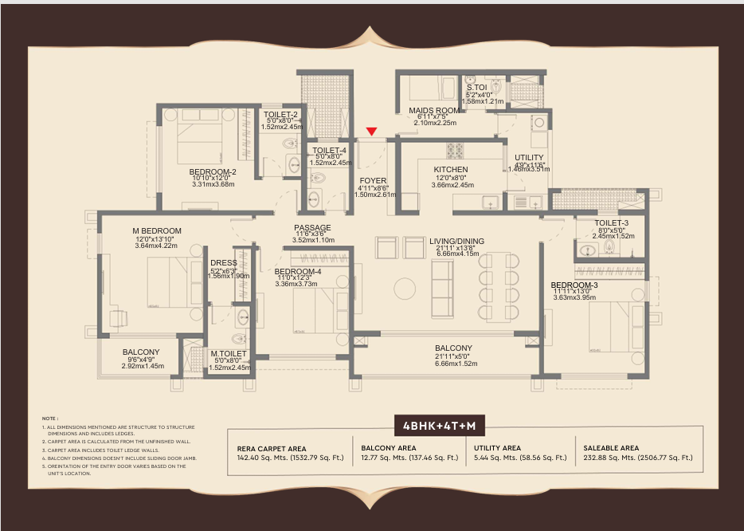
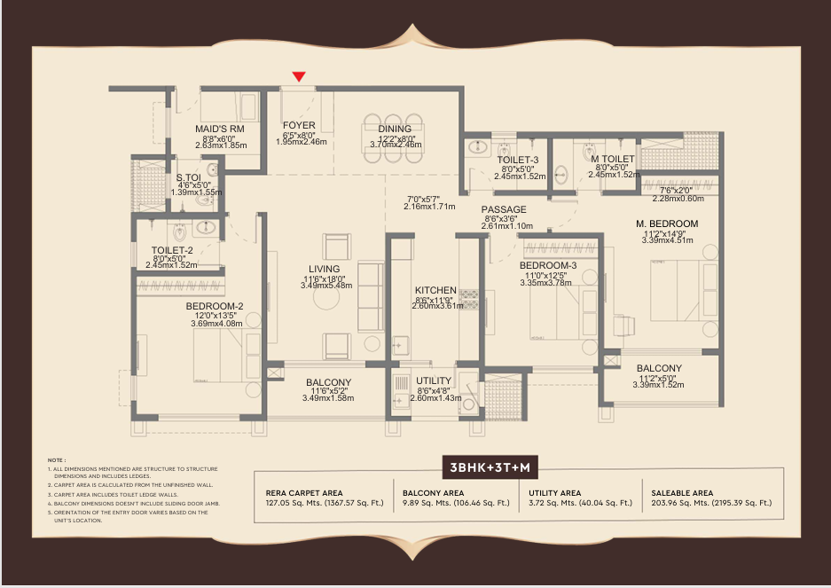

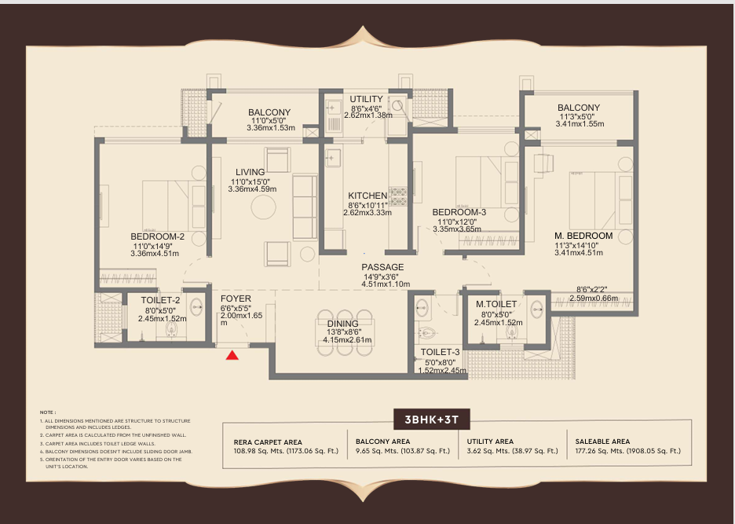

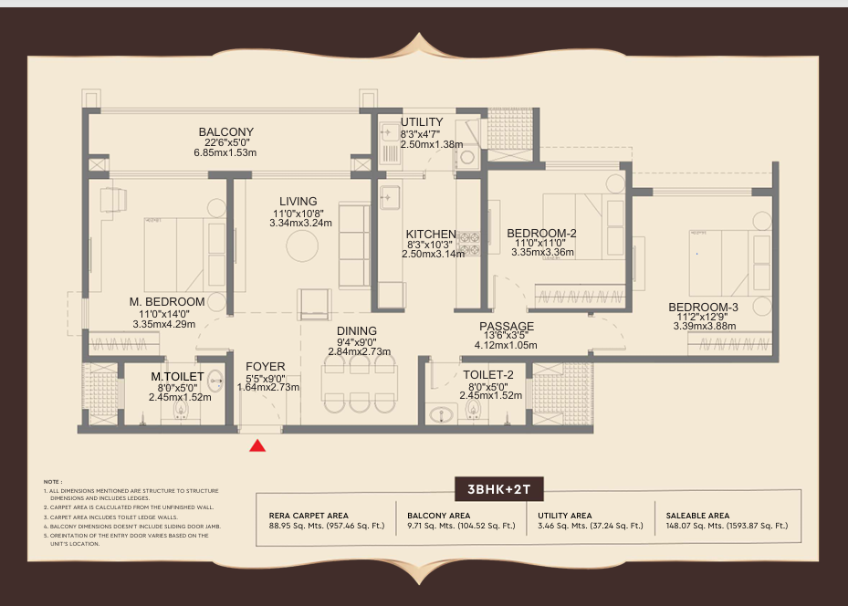

6. Location Advantages
- Kempegowda International Airport -17 km
- Upcoming Peripheral Ring Road - 0.1 km
- NH-44 Bellary Road - 0.5 km
- Upcoming Bagaluru Cross Metro Station - 0.5 km
- Upcoming Yelahanka Metro Station - 1 km
- Satellite Town Ring Road - 26 km

Tech Park
- Amazon Office - 800 m
- Ecopolis Tech Park - 1.6 km
- North Gate - 1.6 km
- Embassy Business Hub - 1.6km
- Bagmane Sierra Business District - 5 km
- Brigade Opus - 6.9 km
- L&T Tech Park - 7.7 km
- Purva Aerocit - 7.8 km

Schools & Colleges
- Canadian International School - 2.5 km
- Ryan International School - 2.5 km
- Millennium World School - 3.7 km
- National Public School, North - 4.4 km
- Vidyashilp Academy - 4.8 km

Hospitals
- Manipal Hospital, Yelahanka - 1 km
- Cytecare Hospital - 1.5 km
- Manipal Hospital, Hebbal - 7.8 km
- Aster CMI Hospital - 9 km
- Bangalore Baptist Hospital - 9.3 km

Malls
- RMZ Galleria Mall - 3 km
- Garuda Mall, Yelahanka - 4.5 km
- Phoenix Mall of Asia - 7.1 km
- Bhartiya Mall of Bengaluru - 8.4 km
- Forum 13 Degree North - 9.5 km
- Elements Mall - 12 km

7. Micro Marketing Understanding
“The project is strategically located bang on NH-44 in Yelahanka, offering seamless connectivity to Hebbal, Airport, and North Bangalore’s key IT hubs.”
The project is situated at Kogilu Cross / Palanahalli on Airport Road (NH-44), Yelahanka. This location acts as the absolute pivot point between established North Bengaluru commercial zones and future economic hubs
Commercial Proximity: It sits directly adjacent to the new Amazon Head Office and opposite the Philips Innovation Campus and Oracle Office spaces. It acts as a primary residential feeder for Manyata Tech Park (Hebbal) and the KIADB Aerospace/Hardware Park near Devanahalli

Transit Infrastructure: Boasts a massive 415-to-450-meter direct frontage on NH-44. It is located less than 500 meters (roughly a 1-minute walk) from the upcoming Bagalur Cross Metro Station on the under-construction Blue Line Airport Metro extension.

Social Fabric: Within a 10-to-20-minute driving radius, residents can access top-tier civic infrastructure, including international schools (Mallya Aditi, Vidyashilp), multi-specialty healthcare (Sparsh, Manipal, Brains Hospital), and retail hubs like The Galleria Mall.

8. FAQs Used By Sales & Pre-Sales Teams
MASTER LAYOUT
What is the distance between the buildings and the metro line? | 35 Mtr/110 ft. (Distance from building 1&9)
What is the OSR (Open Space Ratio)? | 70%, construction area is 30%
TOWER LEVEL
What is the size of ODU space and the entrance of it? | 2.5x4'
What is the staircases measurement?
Service lift specs | 7x10, 1360kg weight capacity
What is the elevator capacity and who is the service provider? | 15 passenger ,1020 kg weight capacity. 6.5x8' (Otis, schinder etc)
APARTMENT LEVEL
What type of doors are we using? | Main Door - Engineered wood door, teak wood frame , vinier finish
 | Bedroom Door – engineered wood
 | Toilet Door – engineered wood
Door width and height. | Main Door- 7'10",width - 3.6' Rest all doors- 3x6.95 , Toilet doors- 2.9x7'
Gap between both utility. | NA
Can we change the design of the maid's room since the maid's toilet is attached with the kitchen wall? | Proposed the Design
Is there any provision for mosquito mesh? | Yes
Can customer opt for a bathtub? | No
Types of tiles used in clubhouse, lobby and reception. | Vetrified , with marble finish
Are the doors facing each other? The distance between two opposite door and side by side door? | 6ft corridor,
Exact setback left from all boundary levels to the towers. | 14 Mtr avg on the sides , front is 20 Mtr, 45 Mtr near PRR
Lift lobby and corridor width | 6ft corridor
Is there a glass partition in the toilet? | No
What is the source of water of the outdoor water bodies and how frequently is it changed ? | Recycled water
Width of the roads in the project | 8 Mtr
Distance between two balconies which are placed beside each other | 30'
Do we provide FTTH provision ? | Yes
What is the paint finish provided in the apartment? | Premium acrylic
CLUBHOUSE
What is the size of the clubhouses and the bifurcation of each ? | 99'x94'
Clubhouse width | 94'
Elevation of clubhouse? | G+3
What is the society office location? | Part of Clubhouse
How many changing rooms will be there near the swimming pool ? | 2 Changing rooms
Are there any drivers toilets in the project? | Yes
What is the size of the banquet hall ? | 125-150 guests capacity
What is the size of the guest rooms? | No
How many entry points are there for the clubhouse? | 1 entry and exit
Does the club house have centralised AC? | No
What is the size & depth of the swimming pools? | Kids- 20 /15 ft. Adults- 80/20 ft
Whether it will be a heated swimming pool? | No
PARKING
What Type of parking do we provide? | Covered- Tandem, stack & parallel
What is the size of each parking we provide? | 8.5ft/ 15 ft 2.5/5.5 Mtrs
What is the process of Parking alotment? | Lucky draw at handover
What is the scope of EV charging points and how many points will be there? | 30% ratio of EV Charging points
How many parkings? | 1600 - Single Parking REST -Double parking
What is the total number of open parking ? | 80 Car parking space for residential
Can a customer buy additional car parking? | Yes
ABOUT THE CONSTRUCTION
Can two flats be bought and combined into one flat? As a duplex ? | Under approval for Jodi units
Are modifications permitted in the apartments? | No
Can buyer choose the flooring/finishing in case he wants ? | No
LANDSCAPES
How many trees and what kind? | 242 trees (171 tree)actual
Artificial water body | 1

Godrej Aveline – Payment Plan FAQ
Question | Answer
How much will my initial booking amount be? | • Your initial booking amount will be 5% of the Agreement Value, payable at the time of booking, along with the applicable 5% GST on the instalment.
 | • The balance 5% is payable within 21 days from the booking date.
How are the remaining payments scheduled? | • After paying 10% at booking, the next 10% is due within 90 days of booking.
 | • Thereafter, payments are linked to construction milestones such as Basement Slab, 3rd, 5th, 7th, 10th, 12th & 14th Floor Slabs, Terrace Slab, Flooring Completion, Occupancy Certificate (OC), and Notice of Possession.
 | • This ensures you pay progressively as the project advances.
Are there any additional charges payable apart from the instalments? | • Yes. Apart from the construction-linked instalments, you will pay GST as applicable on each milestone.
 | • At the time of possession, Advance Maintenance Charges and Sinking Fund Deposit are payable along with applicable 18% GST.

9. Legal Disclaimers
The Project is registered as " GODREJ AVELINE " with Karnataka RERA bearing Registration No. PRM/KA/RERA/1251/309/PR/020326/008501 at https://rera.karnataka.gov.in/ This Project is being developed by Godrej Properties Limited. Site Address: GODREJ AVELINE, SY. NO. 58/1, 64, 65/2 OF VENKATALA VILLAGE, YELAHANKA HOBLI, YELAHANKA TALUK, BANGALORE URBAN, BENGALURU NORTH, BENGALURU URBAN, KARNATAKA - 560064 The official website of Godrej Properties Ltd. is www.godrejproperties.com. Please do not rely on the information provided on any other website. T&C apply

